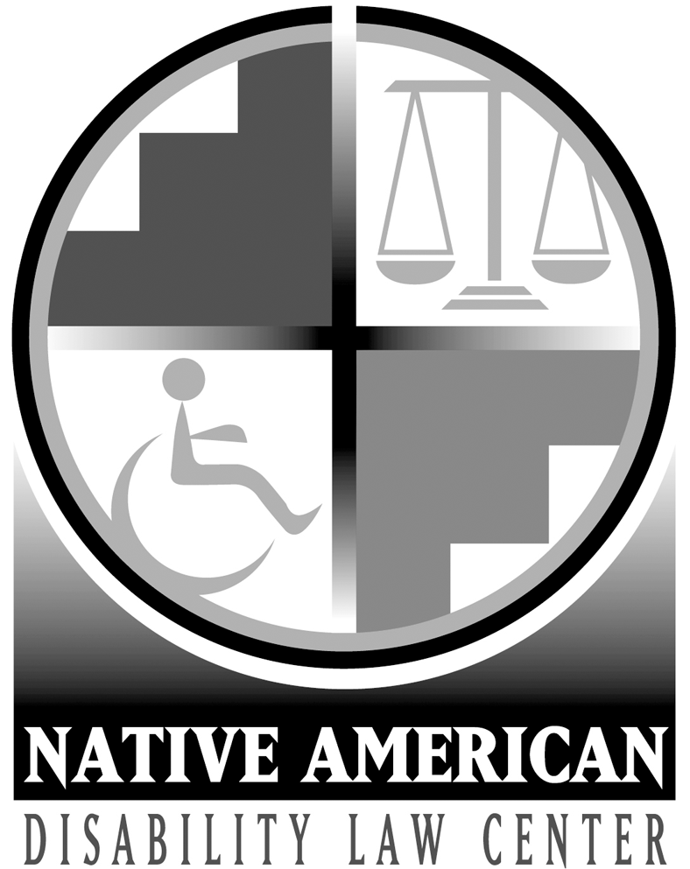

**Statement of Priorities & Objectives**

**October 1, 2024 – September 30, 2025**

**A - Intake & Outreach**

**Goal:** Efficiently provide timely services to new clients & increase awareness of the Law Center’s services through community & media-based outreach, providing training & information.

**Objective 1: Access to Available Benefits.** Assist seniors and individuals with disabilities to receive appropriate services by helping them access programs that pay for healthcare, food and energy.

**Objective 2:** **Promoting Vocational Rehabilitation Services.** Increase awareness of vocational rehabilitation services through:

1. develop & distribute public awareness information and materials; and
2. maintain relationships with vocational rehabilitation programs, transition specialists, and other service providers to ensure awareness of the Law Center’s programs and services.

**Objective 3: Promote Self-Advocacy & Understanding of Rights.**  The Law Center will participate in local, regional & national outreach events, conferences & training events to increase:

1. the understanding of Native Americans with disabilities & their families of their rights to services, supports, & employment;
2. the ability of Native Americans with disabilities & their families to advocate for their needs & services;
3. the understanding of the issues facing Native Americans with disabilities; &
4. awareness of the Law Center & its services.

**B - Children’s Education & Safety**

**Goal:** All Native American children in the Four Corners region will have access to appropriate education & services designed to keep them safe & meet their unique needs in the least restrictive environment.

**Objective 1:** **Represent Abused and Neglected Children.** Represent Native American children as Guardian Ad Litem or Youth Attorney in child abuse & neglect cases in New Mexico and the Navajo Nation through court appointments.

**Objective 2:** **Promote Self-Advocacy.** Provide technical assistance to families of twenty-five (25) students with disabilities to empower them to advocate for their children to obtain appropriate education and related services in the least restrictive environment.

**Objective 3**: **Direct Representation.** Provide direct representation in meetings, informal settings, and/or administrative proceedings to twenty (20) children with disabilities who are not receiving a free appropriate public education in the least restrictive environment, with priority given to students who are excluded from school or who are not receiving appropriate transition services.

**Objective 4: Systemic Advocacy.** Through systemic advocacy,ensure that the federal & state education systems meet the educational needs of Native American students with disabilities enrolled in their schools by addressing their education needs.

**C - Community Integration**

**Goal:** Native Americans with disabilities will be free from abuse and neglect, whether they live in the community, residential facilities, or correctional institutions, & receive appropriate supports & services to enable them to live in the most integrated, least restrictive settings appropriate to their choices and needs.

**Objective 1:** **Monitoring Facilities and Services.** Monitor facilities and institutions at least every six (6) months & more frequently depending on the services provided & the needs of the residents. Monitoring will focus on instances of abuse and neglect, distributing educational materials, and providing advocacy services for individuals who are allegedly being abused or neglected.

**Objective 2: Increase Awareness of Abuse & Neglect.** Develop strategies to increase awareness of the abuse & neglect of adults with disabilities, especially those in group homes & institutions to decrease the incidence & improve the responsiveness of responsible agencies.

**Objective 3**: **Promote Civil Rights & Community Access.** Provide direct assistance to individuals with disabilities in their efforts to protect & enforce their civil rights based on their disability & obtain appropriate community services, such as housing, voting, vocational rehabilitation services or employment.

**Objective 4:** **Advocate for Improved Access to Public Buildings and Services.**

Increase access to public buildings and services for all individuals with disabilities through systemic advocacy.